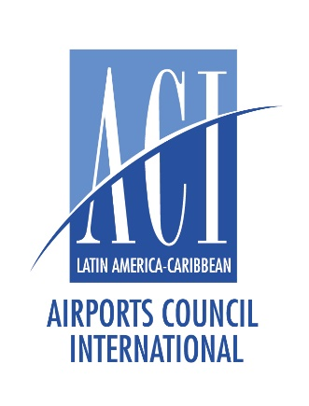**Application Form**

**ACI Latin America and Caribbean**

**Young Airport Professional Award 2025**

**Deadline to confirm participation: August 20, 2025**

**Submission Deadline: September 03, 2025**

*ACI LAC will acknowledge the receipt of each entry application by email.*

**Candidate Information**



|  |  |  |  |
| --- | --- | --- | --- |
| Surname |  | First Name |  |
| Organization |  | Job Position |  |
| Telephone |  | email address |  |

**Nominator Information (CEO / ACI Official Representative)**



|  |  |  |  |
| --- | --- | --- | --- |
| Surname |  | First Name |  |
| Organization |  | Job Position |  |
| Telephone |  | email address |  |

**Other Supporting Documents**



* Candidates are required to submit the following supporting documents **when confirming participation**:
  + Candidate CV
  + Application form signed by the CEO / ACI Official Representative and candidate

**Entrance Declarations**

* I confirm the content of the research paper has not been disclosed previously.
* I agree the research paper being publicized at the discretion of ACI-LAC.

Full name of the candidate:

Date:

*For enquiries, please contact the ACI LAC Office by email to:* [*info@aci-lac.aero*](mailto:info@aci-lac.aero)

Signature of the Candidate:

Signature of the CEO / ACI Official Representative: