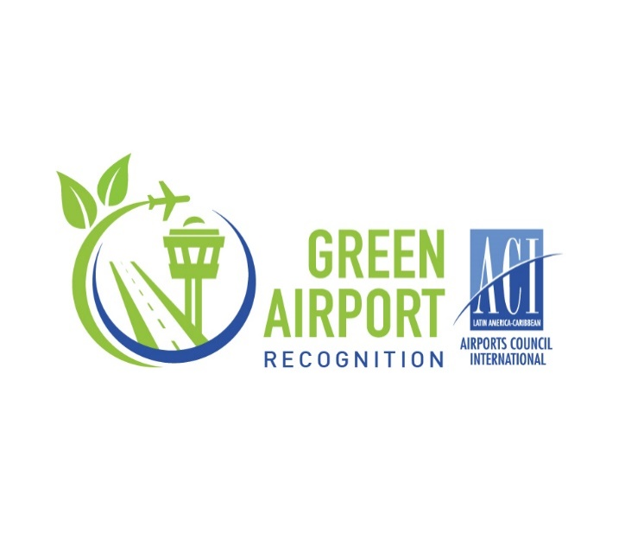**Registration Form**

**ACI Latin America and Caribbean**

***Green Airport recognition* 2025**

**Submission deadline: September 5, 2025**

*ACI-LAC will send an acknowledgment of receipt via email after receiving each form.*

|  |
| --- |
| Name: |
| Airport Group (if applicable): |
| Full name: |
| Position: |
| Email: |
| Project's name: |
| Project website (if applicable): |

* **Participating Airport Information**

|  |
| --- |
| Signature of the official/alternate representative for ACI-LAC: |
| Full name: | |
| Position: | |
| Email: | |

* **Official/Alternate Representative for ACI-LAC**
* **Recognition conditions**

*I accept that the information provided (executive summary and graphics/images) be published at the discretion of ACI-LAC.*



**Biodiversity and Nature-Based Solutions (NbS)**

The **Green Airports Recognition 2025** offers a valuable platform for airports across Latin America and the Caribbean to showcase their successful efforts in biodiversity preservation and the implementation of Nature-Based Solutions (NbS) within the aviation sector. Initiatives may include (but not limited to) wetland restoration and creation, restoring ecosystems, and leveraging NbS for carbon removal. Examples of eligible practices range from in-house horticulture and airport nurseries, plantation for carbon reduction and community benefits, ecological rejuvenation of wetlands, marine life conservation efforts led by airports, and basket of measures for biodiversity.

*Important note*: Projects currently under implementation are eligible, provided they are mature enough to produce measurable, quantitative outcomes in accordance with the evaluation criteria. *Participating airports or airport groups may submit only one (1) project*

* **Evaluation**

Each application evaluated must meet the following recognition criteria:

1. **Involvement of the airport's senior management**

Demonstrate active participation and endorsement from airport senior management during any phase of the project’s development or implementation.

1. **Sustainability Benefit**

Detailed description of the sustainability benefits of the project/program supported by quantitative data and objective sustainability indicators where possible.

Indicate the level to which the project contributes to the United Nations Sustainable Development Goals

1. **Stakeholder Engagement**

Present evidence of collaboration with internal teams and external partners—such as government agencies, NGOs, community groups, or industry stakeholders—in the planning and execution of the initiative

1. **Innovation**

Demonstrate that the project/program exceeds standard industry practices.

In addition, ACI-LAC will present a *Special Recognition* to the project demonstrating exceptional achievement. To be eligible, the participating airport must hold accreditation at any level within the Airport Carbon Accreditation (ACA) program.

The weighting of the criteria for special recognition is indicated below:

1. Involvement of the airport's senior management (20%)
2. Sustainability Benefit (30%)
3. Stakeholder Engagement (30%)
4. Innovation (20%)

* **Instructions to participate.**

Complete and submit the form with the project information in MS Word and send to [fmedela@aci-lac.aero](mailto:fmedela@aci-lac.aero) **before September 05, 2025.**

1. **Summary Executive ( maximum 350 words)**

Please include an Executive Summary of the project in a maximum of 350 words. In case your project meets the criteria of the ACI-LAC *Green Airport Recognition,* this Executive Summary will be included in the Best Environmental Practices Document that seeks to promote best practices that minimize the impact of airports on the environment, in addition to recognizing the achievements of airports in the region in their environmental projects.

|  |
| --- |
|  |

1. **Project Background (maximum 150 words)**

Please describe the background of the project or program (Why was it necessary to develop this project/program?)

|  |
| --- |
|  |

1. **Project scope (maximum 50 words)**

Describe the area of implementation of the project, for example: area of operations, terminal, the entire airport, etc ; as well as agents involved in it: airport staff, other *stakeholders* , NGOs , environmental groups, etc.

|  |
| --- |
|  |

1. **Project Description (maximum 100 words)**

Describe how the project was implemented.

|  |
| --- |
|  |

1. **Project results and benefits (maximum 300 words)**

Describe the results of the project highlighting its achievements. Please emphasize data, for example: cost savings, recognized environmental benefits, evidence of innovation, etc.

|  |
| --- |
|  |

1. **Graphics and Images** **(maximum 4)**

Include a maximum of 4 graphs, including tables or photographs, with a brief description. This information will also be included in the Best Environmental Practices Document.